Fall 2018

CSE221 Quiz: 1

Total Marks: 20

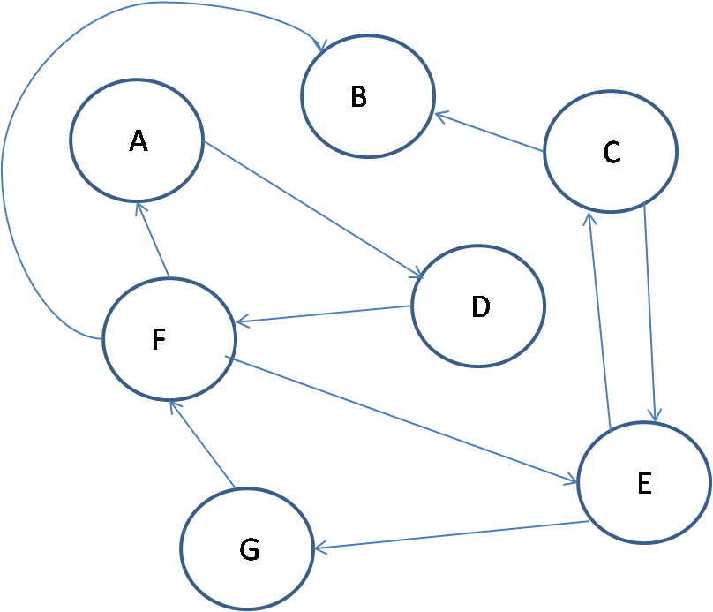

1. When do we use a matrix to represent a graph and when do we use a list? [6]
2. Find the levels of the vertices of the graph. [5]
3. Explain upper bound using curve/equation. [3]
4. Convert the above graph to a tree using an appropriate algorithm. [6]